Central Market Opens in West End
(Farmington Avenue Wire, May 3, 2012)


A new food market has opened on Farmington Avenue in the space once occupied by Cheese n Stuff, a home-grown and beloved natural food store that was cannibalized by a national food chain over a decade ago.

In some ways the new market has similar beginnings as Cheese n Stuff. It's led by a young entrepreneur, 24-year old Adam Hamideh. And he's finding his way in a new market - a small-scale urban grocery store.
Adam Hamideh
Adam Hamideh
It's not a natural foods market, but this product line is increasing. While Adam was stocking the shelves before the store opened, neighbors wandered in and said he had to have organic food. Adam listened and immediately began talking with a supplier and studied up on how what foods he should offer. Soy milk and gluten free products were immediately added to the shelves. He expects his natural food offerings will continue to grow because they are selling well.

The store carries meats - though red meat has not been popular so far. Customers have asked for halal meats and they will be coming soon. Some prices are very competitive with the large chains. For example, the price for a half-gallon of Guida's milk at Central Market is not much more than what it costs to buy at Stop and Shop.

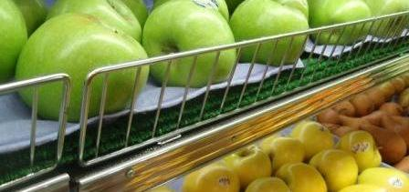
Customers can find a large variety of foods and paper goods at the store. It's stocked with dairy products, beverages, cereals, canned goods, pasta, fresh fruits and vegetables, meats, fish and much more. Shoppers are encouraged to ask for items not currently available so they can be ordered. For example, he was asked to supply goat meat. He did and it quickly sold out.
The store is a family affair. Adam runs the store with his two brothers, Robby and Ayhem and his dad, Yousef. The family moved to the U.S. from Jordan in 1993, living mostly in Windsor Locks and Enfield. Most recently Adam operated a grocery store in Shreveport, Louisiana.

Adam's interest in operating a food store was driven by the economy. People can forgo buying new clothes and electronics when money is tight. But food is essential so is a more recession-proof business.

Originally the Hamideh family had plans to purchase the Bliss Market in Wethersfield. However, the owner of that market died and the deal fell through when it was snagged in probate court. He noticed the market space while doing business at the West End FedEx store and decided it would be a good location for a food store.

Adam is pleased with the welcome he's received from the West End. He said, "It's a great community. I didn't expect to be embraced as I have."

